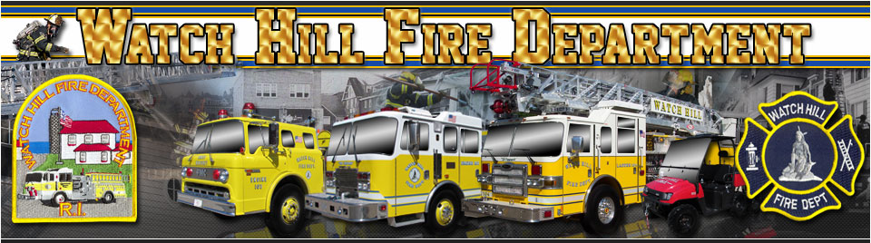

WATCH HILL FIRE DEPARTMENT

Free Public Training Invitation

“Stop the Bleed”

Tuesday, August 13th, 6:30 PM

Please join us for a free one hour public “Stop the Bleed” training class at the Watch Hill Fire Station located at 222 Watch Hill Road.

“Stop the Bleed” is a national campaign to educate the public on what to do to prevent a person from bleeding to death before Emergency Medical Technicians arrive.

Simply put, it is often too late when first responders arrive on the scene of a severe bleeding incident. It will be members of the public with basic bleeding control training that will make the difference between life and death.

Each year more than 5 million people bleed to death after an injury. Many could have been saved by taking the simple steps outlined in this class to “Stop the Bleed”.

This class will empower you to immediately assist victims who are bleeding heavily from an active shooter, or a mass casualty event, or an individual accident.

The goal of this training session is simply to provide members of the public with the basic skills needed to control severe bleeding and to save lives!

The event is free and open to the public. Light refreshments will be provided.

Sponsored by
The Watch Hill Fire Department
